Diary Re-assignment Module
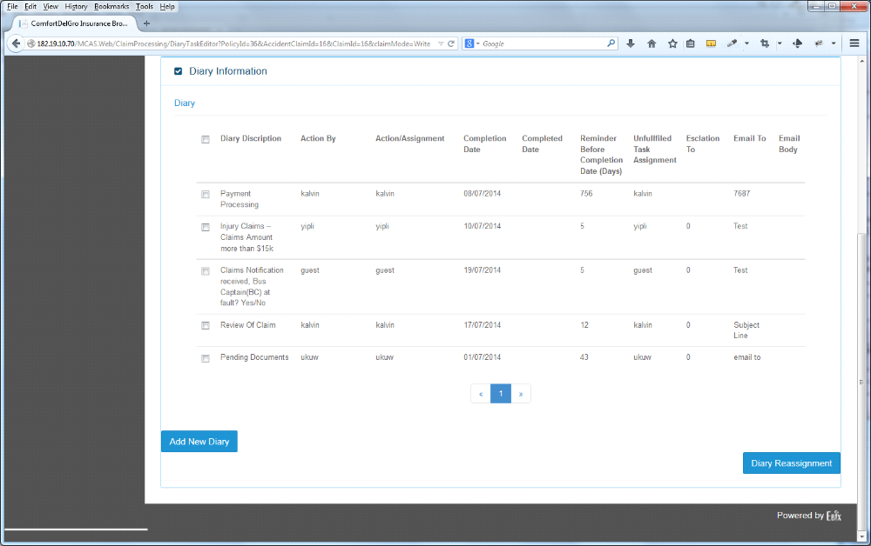

1. Need to have clear indications on this screen for those Entries that have been re-assigned:
- To Who
- Status – Permanent / Temporary
- If Temporary – what is the Time Frame – Re-assigned Date From & Re-assigned Date To
[Varun] Current Process of Diary listing which we are having is mentioned below:
1) Diary associated to a particular user who has logged in, will be displayed in the list.
2) If a user re-assign any diary then that diary will be removed from his/her list and added to a re-assigned user list whenever re-assigned user logged in , he/she can view re-assigned diary.
Question:
* Can both original and re-assigned user see Re-Assigned diary in their diary tab's diary listing or only re-assigned user will see the re-assigned diary, in this case “Diary which are reassigned will be removed from the list in diary tab of original user's login”.
Feedback:

Suggested solution:
* we can add columns on grid:

I) Re-assign status: yes if the diary is re-assigned , no if it is not re-assigned and belongs to original user.

2) Nature of diary: permanent / Temporary
3) Re-assignment Time Frame: << Date from >> To << Date To >>
[Dexter] It will be good that original user and re-assigned user can see the same task. It will be efficient for the original user to see that he has already re-assigned the tasks from his list in a glance.

Question:
* Can we add above mentioned three columns in diary list which is coming on diary tab?
Feedback:
[Dexter] Yes.
2. Users that have received Re-assigned Tasks will be able to see these Cases in their Diary and they have the similar function to re-assign back to the original user or to other users (there are situations whereby this user cannot take on the re-assigned tasks).
Note: if User A has re-assigned a task on a Temporary basis, e.g. from 18 July to 25 July 2014 to User B and User B has to re-assign to User C, the System should take note of this 25 July 2014 date to prevent overlapping of the date.

Point(s) To Discuss: Should the tasks pertaining to a particular claim be re-assigned as a whole to another user or part by part when the original user cannot handle it? If it is part by part – will it be a long list of tasks to be displayed when the re-assigned User views his Assigned Task Listing Module.
Yip – so as not to complicate the process, we provide only 1 only – assign to new party and re-assign back to original party, regardless of temporary or permanent. Multi-party re-assignment will make the process too complex. The original assigning party will lose track of the intended tracking and performance purpose if multiple re-assignment happens.
[Varun]: 1) As per Mr. Yip's comments multilevel assignment (a → b → c) not applicable..
Question:
* Please provide feedback whether below mentioned diary re-assignment can be applicable or not?
1) Multiple diary assigning to multiple user
Details:
* For an example we are assigning three diaries (Diary 1, Diary 2, Diary 3) to three users (user1, user2,user3).
If this case applicable, will diary be assigned in following method?
1) diary 1 will be assigned to all three users, then diary 2 will be assigned to all three users , then diary 3 will be assigned to all three users.
Feedback:
[Dexter] How do we differentiate Diary 1 from a Single Diary Assignment?
2) single diary assignment to multiple user
Details:
* For an example we are assigning three diaries (Diary 1, Diary 2, Diary 3) to only one user (user1).
Feedback:
Dexter]: We may need to consult CDGI if their current workflow requires a Single Diary Assignment to be made available among multiple users
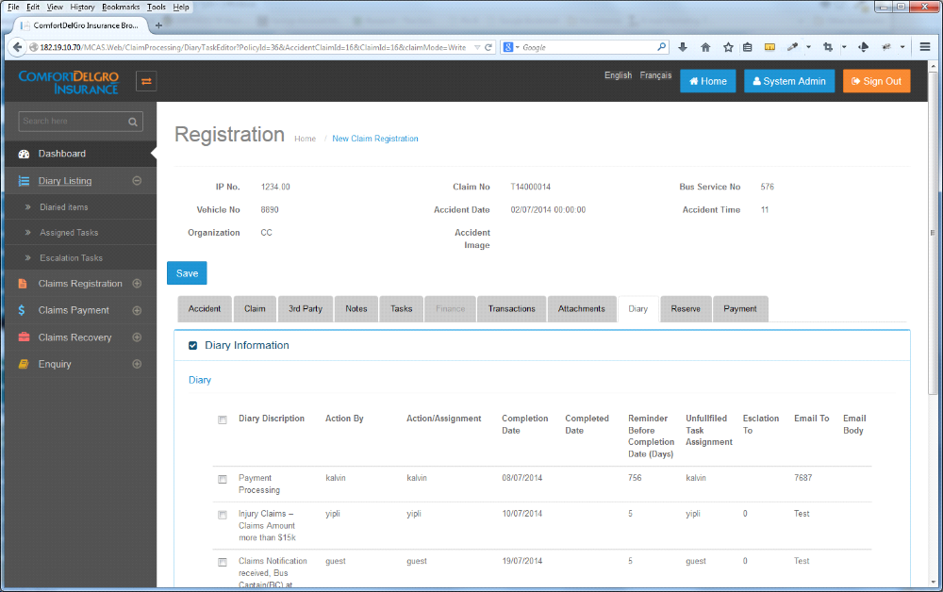

3. Under Diary Listing > Assigned Tasks Listing Module. This is the section for Users to see all their Assigned Tasks and Re-assigned Tasks. There should be a clear indication of Re-assigned Tasks for the Users to see in a glance. This Listing Module should allow Users to perform Re-assignment back or to other Users as well.
Yip – delete the function for receiving party to re-assign to another party. For the three party assignment to effect, the re-assigned party must assign back to original party.
[Varun]:
Question:* Can we put same list of diaries coming in “diary tab” into the “diary listing tab” after adding columns mentioned in point one.
Feedback:
Dexter]: Diary Tab is for the current Claim Number. Diary Listing Tab is to show all the Diary Entries for all Claims.

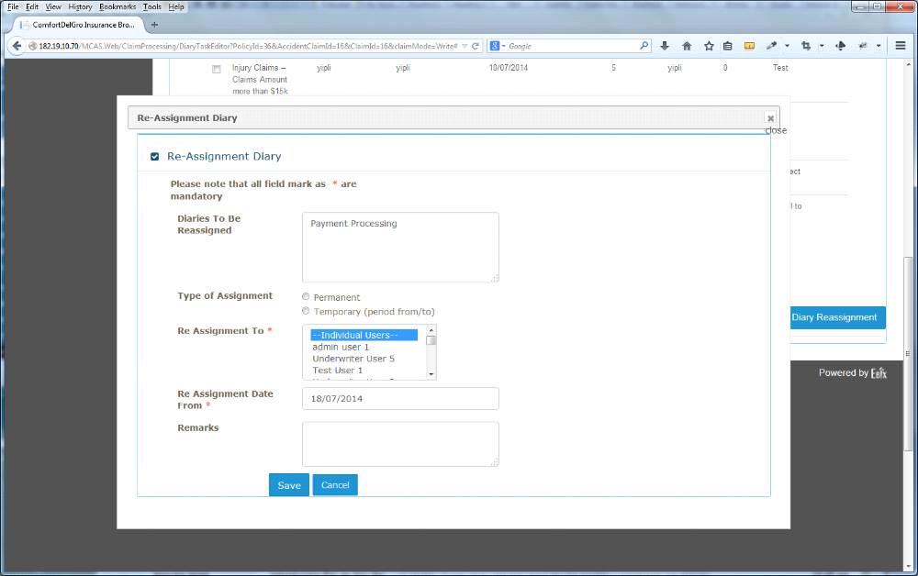

4. There is a missing field – “Re Assignment Date To” when the Temporary Field is chosen.
[Varun]:
I) Re-Assignment Date to field will be visible when user select Temporary radio button from Type of Assignment field .
ii) In case of permanent type of assignment user will not be able to see Re-assignment date to field.
Feedback:
Dexter]: Noted.
5. The Re Assignment To Field should / should not allow multiple users to be re-assigned.
[Varun]: Please provide feedback on this query so that we can proceed.
Feedback:
Dexter]: We may need to check with CDGI on this.

6. When the User clicks on Save – the System will trigger an email and send to the Assigned User(s) that they have received re-assigned task(s).
Sample Email Subject: “Claim #” – You Have Re-assigned Task(s).
Sample Email Body: You have been re-assigned the following tasks for “Claim #”:
- “Diaries to be Reassigned #1”
- “Diaries to be Reassigned #2”
Please kindly check your Diary of Assigned Tasks.
[Varun]: Yes we can add this content to the mail.

